The LNM Institute of Information Technology, Jaipur

End Term Examination (2012-2013, 1 Semester)

Optics and Waves **(Part C)**

Date: 29 November, 2012, MM=60 Time: 1 hour (*to be submitted by 3 PM*)

**Name: Roll Number:**

Marks Obtained = Part I + Part II =

**Instructions**:

* Write your name, roll number just now at the top
* In Part I: Fill in the blanks in this question paper itself
* In Part II: Solve the problems in answer book (mandatory) and circle/tick the correct answer in this question paper with a pen. Neglect very small variation in your answers.
* Negative marking may be given if without solving a question one chooses an answer or your final is nowhere near to the ticked answer.

**Part-I**

Fill in the blanks:

1. The present form of electromagnetic waves were first proposed by…………………………..
2. Given a profile moves with speed 5m/s along the positive x direction . The equation of the progressive wave is …………
3. When white light passes through a prism it splits into many colors because refractive index changes as a function of ……………….………………….. and the process is known as dispersion.
4. If there are two incoherent sources of intensity I0, then the resultant maximum intensity because of interference will be …………………..
5. If  is the electric field associated with light in vacuum then the associated magnetic field is given by …………………………..
6. In standing wave , the length L of the string should be an integral multiple of …………………………….
7. Single mode lasers are useful because of its high ………………………………….compared to multimode laser.
8. The coherent laser light is possible because of an atomic process known as ………………………
9. CO2 lasers are specially used in industry as it gives ………………………..energy in CW mode.
10. The branch of optics which treats light as photons is known as …………………………..

**Part II**

Tick the right answer in this question paper itself after solving it in your answer sheet. If someone ticks the answer without solving it negative marks may be given.

1. The phase velocity of a travelling wave given by the equation in SI unit is given by
2. ) 1.5×107 m/ (b) ) 1.0×108 m/s (c) 2.0×108 m/s (d) 3×108 m/s (e) None of these
3. A wave is specified by in SI unit . The particle speed at x=0 , t=0 is
4. 100 π (b) 120 π (c) 80 π (d) 60 π (e) None of these
5. The amplitude of the electric field associated with a semiconductor laser is 1.73 x 103 V/m. The corresponding magnitude of the associated B field is
6. 5.78 ×10-6 Tesla (b) 6.32 ×10-4 Tesla (c) 8.23 ×10-2 Tesla (d) 1.66 ×10-7 Tesla (e) None of these
7. Three waves given by superimpose at a point P. The resultant amplitude at the point p is
8. 13.92 (b) ) 8.18 (c) 10.43 (d) 6.11 (e) None of these
9. A certain laser has a cavity length of 60 cm. If the laser gain bandwidth of this laser is 3×109 Hz, the number of standing wave modes likely to be present in the laser output are
10. 18 (b) 16 (c) 14 (d)12 (e) None of these
11. A certain mode locked laser gives six pulses per second. If the pulse width is of one pico second (10-12 sec) and the energy deposited by each pulse is 500 mJ , the peak power of the pulse is
12. 5×1014 W (b) 5×1013 W (c) 5×1011 W (d) 5×109 W (e) None of these
13. In a Newton’s ring experiment, the diameter of the 5th dark ring is reduced to ¾ of its value on introducing a liquid below the convex surface, the refractive index of the liquid is
14. 1.78 (b) 1.49 (c) 1.42 (d) 1.25 (e) None of these
15. A diffraction grating has 1.26x104 rulings uniformly spaced over width w=25.4 mm. It is illuminated at normal incidence by yellow light from a sodium vapor lamp. This light contains two closely spaced emission lines (known as sodium doublet) of wavelengths 589.00 nm and 589.59 nm. What is the least number of rulings a grating can have and still be able to resolve the sodium doublet in the first order?
16. 1200 (b) 1024 (c) 999 (d) 600 (e) None of these
17. A beam of X rays of wavelength 0.125 nm is incident on a NaCl crystal at an angle of 45.0o to the top face of the crystal and a family of reflecting planes as shown below. Let the reflecting planes have separation d=0.252 nm. Through what angles must the crystal be turned clockwise about an axis that is perpendicular to the plane of the page for these reflecting planes to give intensity maxima in their reflections ?
18. 20.20, 10.10 (b) 30.60, 15.30  (c) 40.80, 20.40 (d) 8.40, 4.20 (e) None of these

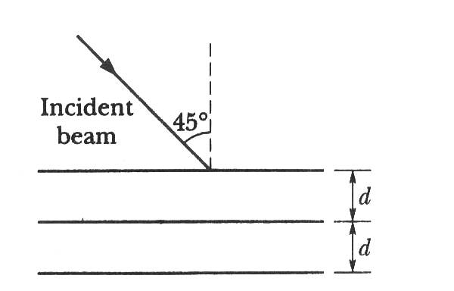

1. A wire having a linear mass density 5.0×10-3 kg/m is stretched between two rigid supports with a tension of 450 N. The wire resonates at a frequency of 420 Hz. The next higher frequency at which the same wire resonates is 490 Hz. Find the length of the wire
2. 2.1 m (b) 2.9 m (c) 3.8 m (d) 4.5 (e) None of these